Online Shopping System: FootFusion

Use-Case Specification: Manage Products -
View Products

Version <1.0>

Revision History
Date | Version | Description | Author
28/11/2024 | <1.0> | Final Draft | Doan Thi Phuong Hong

Table of Contents
1. View Products 4
1.1 Brief Description 4
1.2 Actor 4
2. Flow of Events 4
2.1 Basic Flow 4
3. Special Requirements 5
4. Preconditions 5
5. Postconditions 5
6. Extension Points 5
7. Prototype 5

Use-Case Specification: View Products

View Products

Brief Description
The buyer can easily view product details within the system. By default, the product list is sorted by the date of addition, with the most recently added products displayed at the top.

Actor
The Buyer

Flow of Events

Basic Flow
The buyer accesses the "Cart" section located in the right sidebar, where the system automatically retrieves and displays all products from the database that the buyer has added to their cart.t
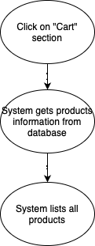

Special Requirements
There is no special requirement.

Preconditions
There is no preconditions.

Postconditions
The system successfully displays all the products in the buyer's cart on the Cart page.

Extension Points
There is no extension point.

Prototype
